Midterm Report

2019250140 Jeon in a

1. Introduction for Kainic acid induced epilepsy model

The kainic acid-induced seizure mouse model is widely used in epilepsy research. Administration of the excitatory toxic substance kainic acid (KA) can stimulate the glutamate receptor and is commonly used to model seizures in rodents. The administration of KA causes the upregulation of reactive oxygen species (ROS) and glutamine activity. The seizure lesions induced by KA are mainly located on the edge of the hippocampus, perfectly mimicking the classical histopathological features of hippocampal sclerosis[1].

The use of KA as a model for epilepsy was first introduced by Ben-Ari and colleagues, who performed a unilateral intra-amygdaloid injection of KA in unanaesthetized non-paralyzed rats and observed focal seizures evolving into SE as the dosage increased. These, and other experiments, suggested using KA as a tool to model TLE in rodents.

Significant advantage of systemic KA administration is (1) its low labor-intensity, which allows the injection of numerous animals in a comparatively shorter time. (2) Moreover, the absence of a surgical procedure eliminates side effects created by anesthesia, surgery invasiveness, and extra damage made by direct contact with brain tissue during the intracerebral injection. (3) Diversity is a hallmark of human epilepsy, even for some specific types such as TLE. Interestingly, KA models are also very diverse. The results vary as a function of how KA is administered, species, strain, sex, and age. This is a strength as the different models may cover some of the patients’ diversity.

However, this model’s obvious disadvantages are (1) no control over the bioavailability of KA in the brain and (2) high mortality rates. (3) It is important to note that KA is quite expensive and (4) that the purity of the molecule can vary from personal experience. (5) There are also different forms of the drug, e.g., pure acid and its dehydrate, which can sometimes be an issue in terms of result variability[2].

1. Make figure for KA experiment
2. Experiment condition

Kainic acid was injected into the kainic acid-induced group mice, and saline was injected into the control group mice. The kainic acid was dissolved at a concentration of 5mg/ml and 0.192 ml was injected to experimental group. The mice were given intraperitoneal (I.P.) kainic acid injections. After injection, the mice were evaluated according to an established six-point seizure scale at 5-min intervals for 75-min. The seizure score was determined through observation of the behaviors associated with corresponding levels. The higher the score, the more severe the seizure is. It was confirmed that seizures with a score of 3 were induced within 25min after kainic acid administration.

1 week after the experiment, all mice were anesthetized in a chamber using isoflurane. Brain tissues were extracted and fixed with 4% PFA for 1 week. The fixed tissues were embedded in a agarose gel and sectioned into 15μm thick sections. The sections were then mounted on slides and stained with Cresyl Violet solution. After staining, hippocampus of the brain was scanned and we used image analyzer software ImageJ, the density of cell was calculated.

1. Seizure score

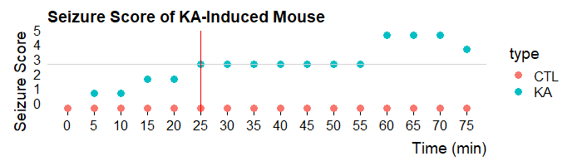 Compared to the control group, the KA-induced mice showed seizure over time, and after about 25 minutes, stage 3 began.

1. Representative images

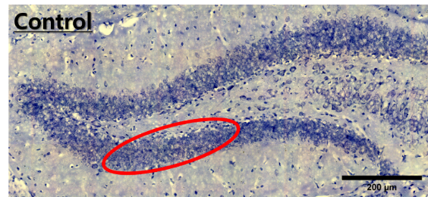 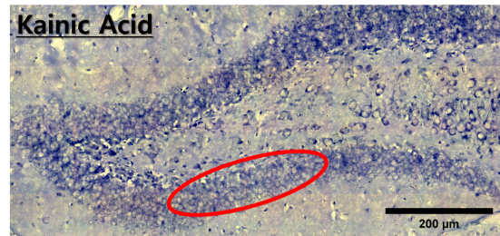

It showed that the hippocampus cell number of KA-induced mouse is less than control group. For accuracy, we used imageJ that can measure cell density.

1. Cell counting bar graph

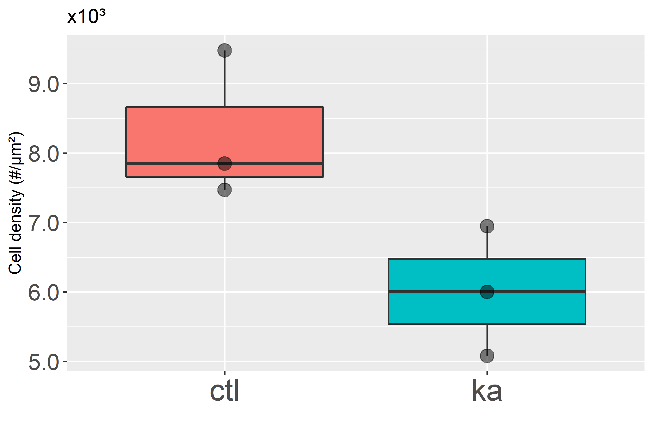

As shown above, the hippocampus cell density of KA-induced mice is significantly less than control group. Each group consisted of three data.

1. Reference

[1] Kang, KK., Kim, YI., Seo, MS. *et al.* A comparative study of the phenotype with kainic acid-induced seizure in DBA/2 mice from three different sources. *Lab Anim Res* 36, 39 (2020).

[2] Evgeniia R, Christophe B, Adam W. The Kainic Acid Models of Temporal Lobe Epilepsy. *eNeuro, Society for Neuroscience*, 2021, 8 (2).